

PILGRIMAGE HELPERS' HANDBOOK

MIDDLESBROUGH DIOCESAN PILGRIMAGE TO LOURDES

HELPERS HANDBOOK

CONTENTS

MIDDLESBROUGH LOURDES HOSPITALITÉ 4

What is the Lourdes Hospitalité? What do Helpers Do?

Training; Disclosure and Barring Service

WORKING AS PART OF A TEAM 5
General Guidelines; Dress Code

DUTIES AND TASKS 6
First Day; Domestic Duties; Kitchen/Refreshment Duties;
Communication Skills

PERSONAL CARE 8
Assisting Supported Pilgrims with Going to the Toilet;
Washing; Showering; Clothing; Eating

HEALTH AND SAFETY 11
General Guidelines; Smoking; Hand-washing

SAFE MOVING AND HANDLING 15
Moving and Handling Supported Pilgrims and Objects

WHEELCHAIRS 17
Transferring to a Wheelchair; Pushing a Wheelchair

GOING OUT 18
Escorting Supported Pilgrims Out of the Accueil;
Escorting Supported Pilgrims Out of the Domain

SAFEGUARDING 19
General Guidelines; Confidentiality, Free Time

EMERGENCIES 20
First Response to Medical Emergencies; Fire

GLOSSARY/DEFINITIONS 21

THE DIOCESE OF MIDDLESBROUGH LOURDES HOSPITALITÉ

The Lourdes Hospitalité is a group of volunteer helpers of all ages and backgrounds, whose role is to enable and enrich the pilgrimage experience of all pilgrims, but particularly those who need additional support due to age, illness or disability.

Most of these 'Supported Pilgrims' stay in the Accueil, or 'place of welcome'.

The Hospitalité is made up of doctors, nurses, male and female helpers (brancardiers and handmaids), young people's group leaders and musicians.

What do Hospitalité Helpers Do?

The most important role of all Hospitalité volunteers is to spend time with Supported Pilgrims. Whether socializing or just spending time talking this time spent together is a privilege that is often hugely rewarding.

The doctors and registered nurses are also responsible for the medical needs of Supported Pilgrims, and the helpers work alongside the medical team to help with personal and social care, meals and some domestic tasks. Brancardiers are responsible for the Banners being in the correct position for the processions.etc.

The specific duties and responsibilities of helpers are outlined in this handbook.

If you wish to take an active part in any services by reading etc or take an active part in the processions please let your team leader know.

Training

Prior to each pilgrimage, all helpers are required to attend a day of Formation which will include some mandatory training session, this day forms the basis of all working procedures. No exceptions can be made.

Disclosure and Barring Service

All helpers must have current clearance from the DBS (formerly CRB) prior to the pilgrimage.

WORKING AS PART OF A TEAM

The team caring for Supported Pilgrims includes the pilgrimage officials, the young people, the clergy and multi-disciplinary teams of helpers.

1. Once you have been allocated to a team, consult the duty rota and ensure you turn up in good time for every shift.
2. If, for some reason, you are unable to turn up for a shift, will be arriving late or leaving early, make sure you inform your team leader in good time.
3. As shifts can be very tiring, make sure you get enough sleep.
4. Try to stay positive, keep smiling and perform tasks willingly, even when you find things (and people!) difficult or irritating.
5. Follow instructions given by your team leader or the Head Nurse, however, if you feel that you are unable to carry out a task, please do not hesitate to say so.
6. If unsure about anything, however small, ask for help or clarification.
7. If you have difficulty remembering everything that you are told, carry a notebook and write information down.
8. When you have completed a task, report back to your team leader so that he/she knows that it has been completed.
9. Young people should only be asked to undertake any task through their group leader.
10. If anyone is in need of help, offer assistance or stay with them and send for help.
11. If you are unhappy or concerned about anything report it to your team leader.
12. Use the de-brief meeting at the end of the shift to comment on anything that has gone well, try to resolve problems that have occurred (without finding fault) and pass on information about any unfinished tasks or issues that will be relevant to the next shift.

Dress Code

- Female helpers wear a blue dress or tunic with white belt
- Registered Nurses have a Navy Blue Uniform
- Male helpers wear a blue Brancardier jacket and bretels
- Alternatively, all helpers may wear a blue Hospitalité polo
- All helpers must wear flat, comfortable shoes (not flip-flops)
- All helpers must wear a name badge
- All helpers must be bare below the elbow in the Accueil
- For processions, men wear a shirt and Hospitalité or other dark tie and women may wear a white cardigan

DUTIES AND TASKS

Arrival on the First Day

1. When first arriving on the ward, orientate yourself, find out where everything is and who people are.
2. Find out what to do in the event of an emergency, where the emergency exits, fire alarm points and fire extinguishers are.
3. When the Supported Pilgrims have settled in, check luggage is there and if anything is needed.
4. Any food, should be disposed of or stored appropriately.

Domestic Duties

- Find out where personal protective equipment, linen and disposal bags are kept.
- Ensure that wards, toilets and bathrooms are clean throughout the day.
- Put used linen (sheets and blankets, etc) into laundry sacks.
- Launder clothing if it becomes imperative to the hygiene of Supported Pilgrims.
- Make beds to Accueil standard.

Kitchen and Refreshment Duties

- Wear a blue plastic apron when working in the Accueil kitchen or serving food.
- Ensure that the kitchen is kept clean and tidy.
- Collect cups from the ward area, roof terrace and corridors, return them to the kitchen and wash them.
- Keep water urns full and make sure plenty of drinking water is available.
- Ensure that water flasks are full and available to take to services.

Last Day

- All helpers are asked to go to the Accueil and help with packing, cleaning and making beds (training given by Accueil staff).
- Look out for things that have been forgotten, and volunteer to do the jobs no one else wants to do, and the ones that you feel someone else really ought to have done - with a smile if you can manage it!
- Communication Skills

One of the most rewarding aspects of the pilgrimage and working on the ward is having the opportunity to talk with the Supported Pilgrims. Talking with people allows them to share their knowledge and experience, their joys and their fears, and shows them that they are valued and cared for as individuals, as well as developing friendships. Do make the effort, even if you don't find it easy to talk to people. The following tips might help:

- Make a special effort to talk to people who are on their own or are not so easy to talk to.
- Avoid putting yourself into a compromising situation with a pilgrim when having a conversation.
- Before initiating a conversation, introduce yourself, find out who they are and make sure they would like to have a chat.
- Respect the person and don’t be too familiar.
- Be patient, smile and keep listening, even if it is difficult.
- Maintain eye contact and a comfortable personal space.
- If the person is hearing impaired, sit facing them, in good light and speak clearly, without shouting, and using gestures, body language and facial expressions to aid understanding.
- Try to ask open questions that require more than a yes or no answer.
- Ask about the pilgrim’s background and experiences and let them talk about themselves.
- Look for common ground and interest.
- Remember that the Supported Pilgrim may be as interested in you as you are in them, so be prepared to give information about yourself, but only as far as you are comfortable with, and take care not to dominate the conversation.
- Maintain confidentiality, and if you have any concerns, pass them on to the team leader, without breaking confidentiality.

Prayer

Prayer is central to our pilgrimage and there are many opportunities for prayer built into our programme of activities for the week. In addition to this, praying together as a team reinforces the purpose of our pilgrimages, strengthens bonds and builds trust.

Praying with a Supported Pilgrim, whether at the Grotto or in the Accueil can have a powerful effect on both parties and helpers are encouraged to do so whenever they feel it is appropriate.

PERSONAL CARE

- Personal care includes taking supported pilgrims to the toilet, washing, showering and assisting supported pilgrims with eating.
- People carrying out personal care must be over the age of 18.
- All personal care carried out by helpers will be under the supervision of the nursing team.
- Remember that the Supported Pilgrim will usually know exactly what they want and how they want it done. If in doubt ask them.
- If you are unsure of what to do, a member of the nursing team or one of the experienced helpers will be happy to give you advice, assistance or show you how to do it.
- Helpers should always work in pairs.
- If possible, avoid entering bedrooms unaccompanied, particularly the bedroom of someone of the opposite sex.

Assisting Supported Pilgrims to Go to the Toilet

The helper should be same sex or a nurse.

1. Respond promptly to a request for the toilet and enlist the support of another helper or Nurse.
2. Ask the person how they would like to be taken to the toilet. 3. Encourage the person to do as much for themselves as possible, taking into account the urgent need for the toilet. 4. If the Supported Pilgrim needs to be transferred to the toilet from a wheelchair, the task needs to be well planned, as there is little room for manoeuvre in the toilets.
5. To preserve dignity, as few people as possible should assist in the toilet.
6. Once on the toilet, the person should be left in privacy until they are finished.
7. While the person is using the toilet, a helper should stay outside, close at hand ready for when they are finished.
8. If necessary, when the person is finished, assist them in cleaning themselves and adjusting their clothes.
9. If the person uses continence products, you can ask a nurse or experienced helper for advice about use.
10. Give the person the opportunity and encourage them to wash their hands before returning them to where they want to go.

Assisting Supported Pilgrims with Washing

1. Before starting, make sure that you have toiletries, towel and anything else that you will need.
2. Ask the Supported Pilgrim exactly what they want assistance with and encourage them to do as much for themselves as possible.
3. Give the person the opportunity to clean their teeth,
or put them in to soak.
4. Give them the opportunity to use talc or deodorant and comb or brush their hair.
5. If they wish and you have the ability, you can assist with cosmetics.

Assisting Supported Pilgrims with Showering

The helper should be same sex or a nurse.

1. Always ask another helper to remain close by for you to summon assistance when necessary.
2. Find out what the person wants assistance with and encourage them to do what they can for themselves.
3. Have everything you need to hand, including a towel, and remembering that the person may need a shower chair or a stick.
4. Ensure privacy, close door and try to eliminate draughts.
5. Hold shower head away from the person until it is warm, then allow them to check the temperature is comfortable for them.
6. Ask the person what order they would like things done and what products they would like to use.
7. When the person is finished showering, help them to get dried if necessary
8. Give them the opportunity to use talc or deodorant and comb or brush their hair.
9. If the person needs transferring, make sure they and the floor are dry before making the transfer.
10. Make sure the person's dignity is maintained throughout, especially if they are not fully dressed before leaving the bathroom.

Assisting Supported Pilgrims with Clothing

The helper should be same sex or a nurse.

1. Find out what the person wants assistance with and encourage them to do what they can for themselves.
2. Ensure privacy, close curtains and eliminate draughts. 3. Have everything you need to hand, as it causes delay and can be unsafe for you to leave a Supported Pilgrim to go and get something that you have forgotten.
4. Give the person choice in what they want to wear.
5. Put clothing onto a less able limb first and when undressing, remove clothing from the less able limb last.
6. Remember glasses, teeth, hearing aids and walking sticks.

Assisting Supported Pilgrims to Eat

1. Before assisting anybody with a meal, wash your hands and put a plastic apron on.
2. Sit on whichever side is best for you and the Supported Pilgrim and make sure that you are both comfortable.
3. Introduce yourself and find out what the pilgrim likes or dislikes at mealtimes or if they require a special diet.
4. Find out what the Supported Pilgrim can do for themselves and enable them to be as independent as possible.
5. Join in the conversation at table and if necessary encourage the person that you are assisting to join in.
6. Cut food into small bite sized pieces and take your time, waiting for the person to finish one mouthful before giving them the next one.
7. If the Supported Pilgrim is on a soft diet, keep all the elements of the meal (meat, vegetables, potatoes, rice or pasta, etc) separate to preserve the different tastes.
8. Ensure that the person has enough to eat and drink but never force food on them.
9. Ensure that the Supported Pilgrim’s mouth is kept clean.
10. At the end of the meal, ensure that the Supported Pilgrim is not left alone at the table and is enabled to go where they wish to go.

If you think someone may be choking, stay with them and call for one of the medical team immediately.

HEALTH AND SAFETY

1. For general duties around the ward, wear a white apron and change it for each Assisted Pilgrim you work with.
2. Use protective gloves for messy jobs or handling anything with a risk of infection.
3. Do not wear gloves any longer than necessary, as they quickly become ineffective.
4. Wash your hands or use the alcohol gel provided on arrival and before putting gloves on and when taking them off.
5. To prevent cross infection, when coming on duty in the Accueil, between tasks, after going to the toilet, before working in the kitchen or serving meals, and going off duty wash hands thoroughly, and use the alcohol gel

6. To avoid accidents, people slipping on wet surfaces, tripping up or falling over all areas, including passageways should be kept clean and clear of obstructions.
7. All spillages or accidents should be immediately cleaned up and wet or slippery areas should be clearly indicated.
8. If any tablets or unused medication is found anywhere it should be handed in to the nurse in charge.
9. Clinical waste is disposed of in yellow plastic bags.
10. Sharps (used razors & syringes, etc) are disposed of in a yellow 'sharps box'.
Never put your hand into the sharps box.
11. All other waste is disposed of in black plastic bags.
12. Cleaning materials and detergents and other hazardous liquids and materials should be used in accordance with the manufacturer’s instructions. If in doubt, ask.
13. All cleaning materials, detergents etc. should be safely stored in the cleaning cupboard and returned after use.
The COSHH assessment (information on the cleaning materials) will be in the cleaning cupboard.
14. If any hazardous material or liquid is splashed into the eyes, swallowed or any other accident occurs, see the nurse in charge immediately.
15. Read and follow all Safeguarding instructions.

Smoking

Smoking is not allowed in the Accueil, or Domain, although Supported Pilgrims are allowed to smoke on the roof terrace. Helpers should ask the nurse in charge before taking a Supported Pilgrim for a cigarette and should remain with them until they are ready to return.
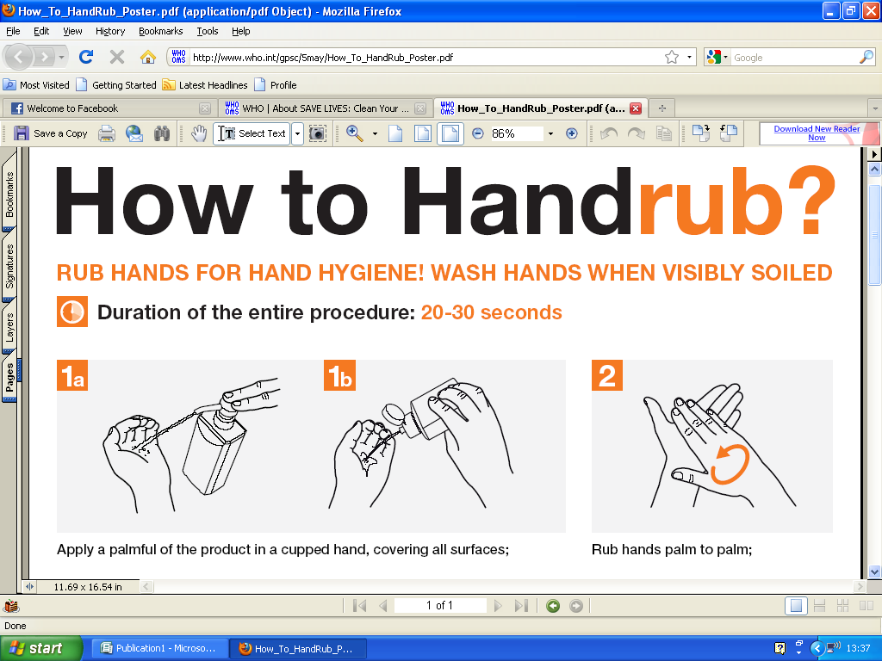
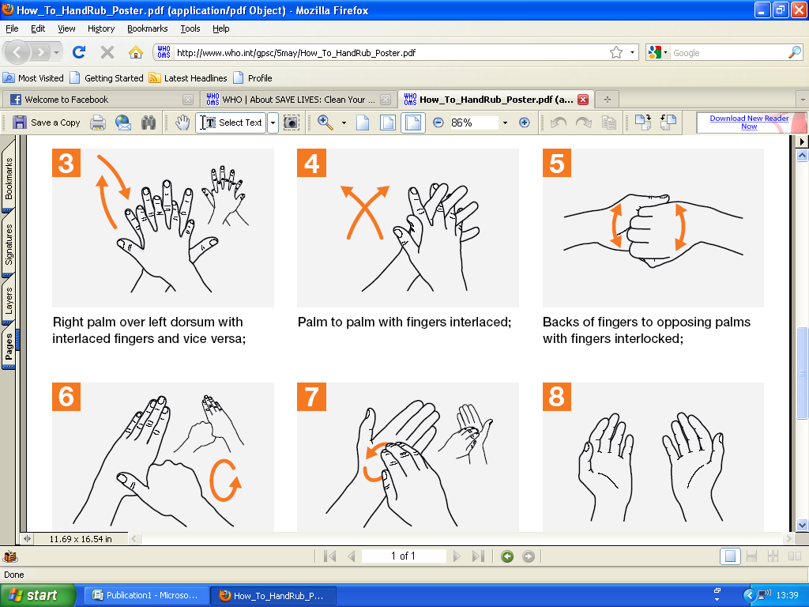
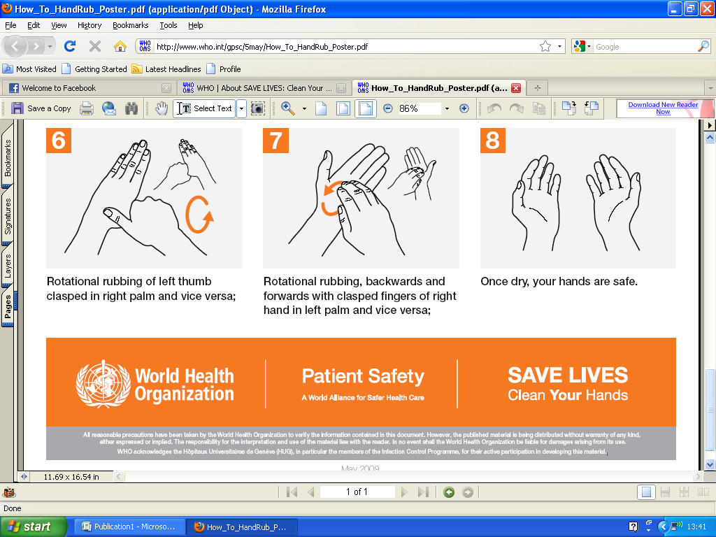
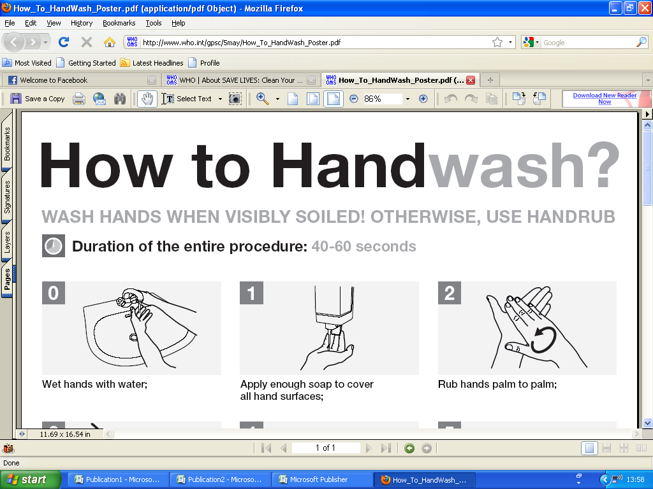
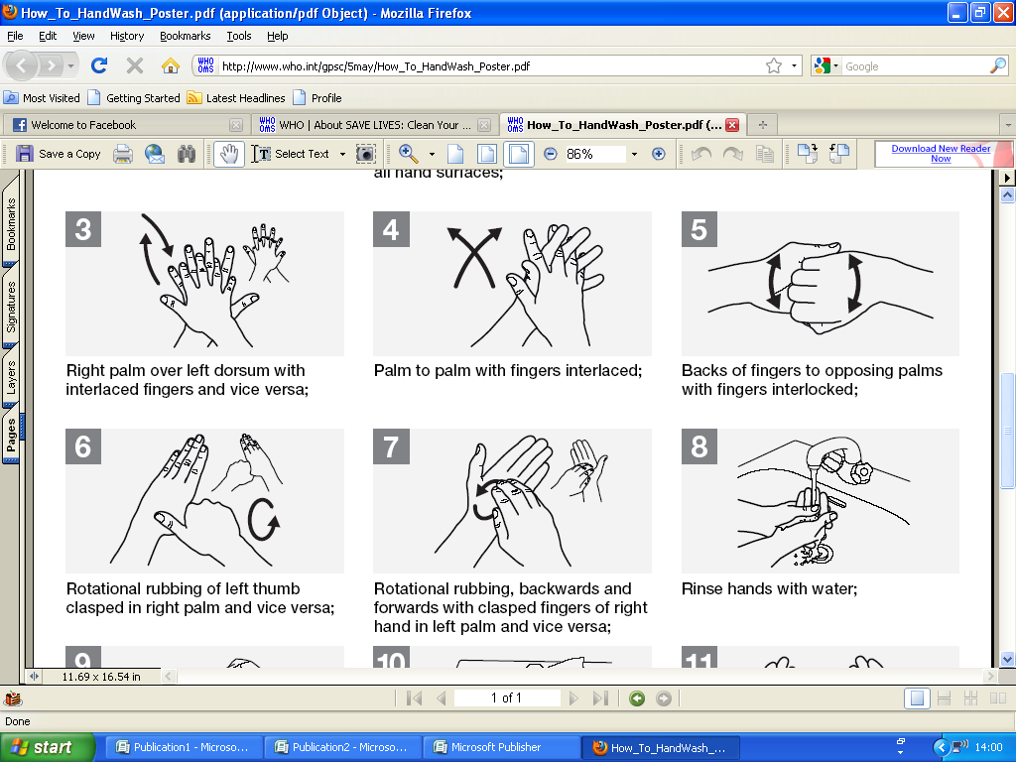
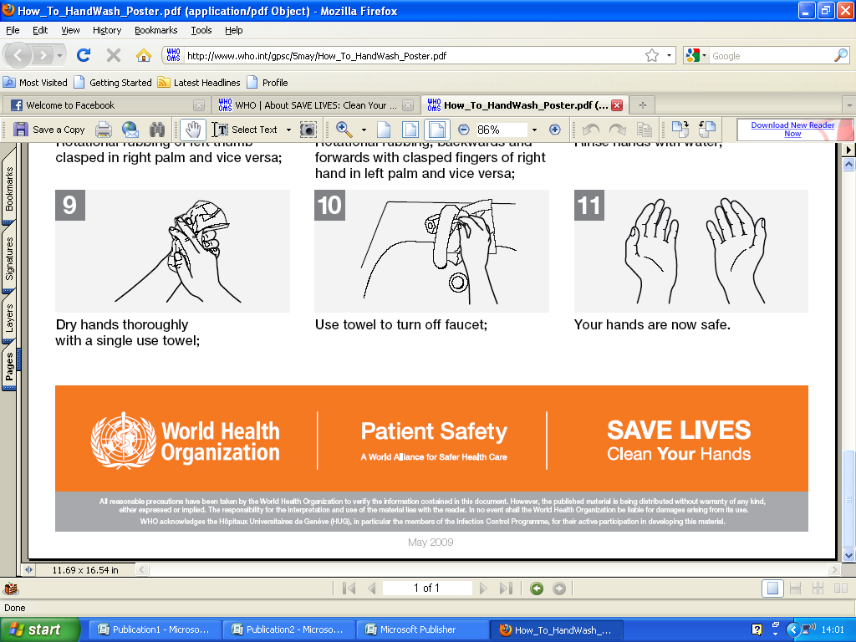
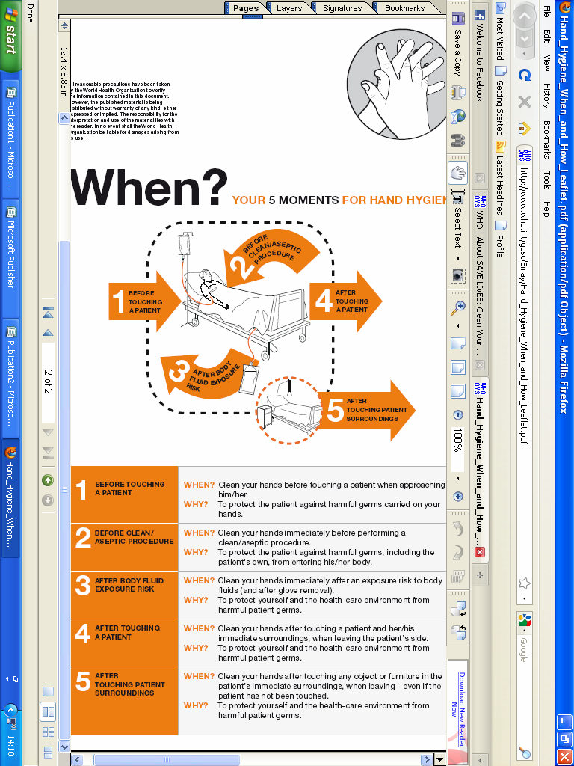

SAFE MOVING AND HANDLING

The following principles apply, whether moving and handling people or objects (such as cases and equipment).

- Know your own limitations and do not exceed them.
- Never do or lift anything that you are unsure of.
- Wear suitable clothing and footwear.
- Avoid moving and handling if you are pregnant.
- Assess the person or load before commencing each task and if necessary, call for help.
- Clear away obstacles and obstructions.
- Make sure floors are dry.
- If you or anybody else involved is uncomfortable, then stop and reassess the task.
- Never carry objects up or down stairs. Always use the lift.

Moving and Handling Supported Pilgrims

- Refer to any step by step guide at the end of a Supported Pilgrim's bed.
- Describe to the Supported Pilgrim what you are going to do and ask for their co-operation and advice on how the transfer is best achieved.
- Have everything in place before commencing the transfer. If more than one person is involved in transferring the sick pilgrim, nominate one lead person.
- Commence the transfer on the instruction “ 1, 2, 3, go.” Be confident, holding the Supported Pilgrim as close to your body as possible, and using personal protective equipment if necessary.
- Transfer over the shortest distance possible (stand up, turn and sit down).
- When bathing a Supported Pilgrim, ensure they are dry before starting transfer to avoid accidents.
- Never use a drag or through arm lift, whether out of a chair or up a bed.
- Use the hoists and moving and handling aids available.
- If using a hoist always use the Supported Pilgrim's own sling to avoid cross infection.
- If you see unsafe situations or practices, please report them to the Head Nurse or Team Leader immediately.
Moving and Handling Objects

- If possible, turn, slide or roll objects rather than lifting and use trolleys and wheels to move objects from place to place.
- Divide loads and make several trips - never lift heavy loads or loads that prevent you from seeing where you are going.
- Move or turn objects towards you rather than away from you.
- Stand close to the object to be moved.
- Stand with your feet hip width apart, with one foot in front of the other - this cannot be achieved in a tight skirt.
- Face the load and avoid rotation of the spine, holding your shoulders and pelvis in the same plane, shoulders level, elbows flexed and close to your body.
- Bend your knees and raise your head on commencing the lift, keeping your back in natural alignment, not leaning to one side.
- Use smooth, rhythmic movements and keep moving if possible, as sudden jerks may cause severe strains.
- Curved movements are often quicker and less tiring than straight ones with sudden changes of direction.
- If you have any problems or difficulties with moving and handling, see the team leader in charge.

WHEELCHAIRS
Inexperienced helpers should not transfer anyone or push a wheel chair unless accompanied by an experienced helper.
The dignity, comfort and safety of Supported Pilgrims must be maintained and Seatbelts used at all times.

Transferring to a Wheelchair

1. If you do not already know the Supported Pilgrim, introduce yourself, ask their name, say what you intend doing and ask how they prefer to be transferred.
2. Make sure you have the correct wheelchair and after unfolding it, make sure that it is rigid, all the catches are on and it is not likely to fold up when somebody sits in it.
3. Make sure that the Supported Pilgrim has shoes on and is appropriately dressed (protected from the sun/warm enough when sitting still outside).
4. Check that the brakes are on and the footplates are raised and folded back. Check the cushion is in place.
5. Transfer the less able pilgrim with confidence and with another person if necessary.
6. Before moving off, ensure that the footplates are in the correct position and that the Supported Pilgrim has their feet firmly on them and has the seatbelt fastened.

Pushing a Wheelchair

1. Check that the Supported Pilgrim is comfortable and has everything that they need.
2. Ensure that the Supported Pilgrim keeps their elbows in and that their feet do not get trapped under the footplates.
3. Be aware of people around you. If people are in the way, politely ask them to move and avoid catching heels/ankles.
4. Move forwards onto pavements and backwards off them, always remembering to tell the Supported Pilgrim what you are about to do.
5. Always put on the brakes when you stop.

On Return

1. When transferring a Supported Pilgrim from a wheelchair, ensure that the seatbelt is unfastened, the brakes are on and the footplates are raised and folded back.
2. Ensure that the Supported Pilgrim has all their belongings.
3. Wheelchairs should be stored folded with footplates raised and folded back.

GOING OUT

Inexperienced helpers should not take a Supported Pilgrim out of the Accueil unless accompanied by an experienced helper.

Escorting Supported Pilgrims Out of the Accueil
1. Ensure that the Supported Pilgrim has everything they need.
2. In hot weather you and the sick pilgrim need sun protection, cool clothing, head covering and plenty of fluid.
3. Whenever possible, find an area in the shade.
4. In wet weather the Supported Pilgrim will need waterproofs, a head covering and blankets.
5. Before leaving the ward sign out, the supported Pilgrim. Also inform the duty team leader, and tell them where you intend to go and your expected time of return

Escorting Supported Pilgrims Out of the Domain

1. Whenever a Supported Pilgrim is taken out of the Domain,
there should be two helpers, one of whom is over the age of 18 and able to provide social care.
2. Ask the Supported Pilgrim where they would like to go (taking into account the hills and your ability) and whether they would like to be with friends or a partner.
3. Before leaving the ward sign out, the Supported Pilgrim.
4. If the Supported Pilgrim wishes to go for a drink, check with the nurse in charge before you go, as alcohol can interact with medication. Remember that alcohol not only impairs judgement but is also an inadequate way of maintaining fluid levels for both you and the Supported Pilgrim.
5. Do not handle a sick pilgrim’s money without a witness and do not accept cash gifts.
6. If a problem arises, one helper should go and get help while the other stays with the Supported Pilgrim.
7. On return, ensure that all possessions have been retrieved from the back of the voitures and from the inside of blankets, etc.

8. Fold and return blankets and waterproofs.

9. Remember to sign back in.
SAFEGUARDING

Safeguarding the dignity and well-being of all pilgrims is of paramount importance to The Hospitalité. In this regard, particular consideration must, of course, be given to the children and vulnerable adults in our care and the organisers and medical team follow all relevant guidance in planning and running the pilgrimage. It is essential that all helpers share this responsibility.

- All helpers must have DBS clearance before pilgrimage.
- All helpers must attend training session before pilgrimage.
- Helpers must ensure that they have had adequate sleep and are not under the influence of alcohol when on duty.
- Helpers must ensure that the dignity of each and every Supported Pilgrim is maintained in all circumstances.
- Always follow guidance given in section on personal care.
- Always follow health and safety guidance.
- Always follow guidance on moving and handling.
- Be alert to ward security at all times.
- If you see strangers on the ward, offer assistance and ask who they are visiting, or refer them to the team leader.
- Two helpers must remain on the ward when the Supported Pilgrims are out at services.
- If you see or hear anything that causes you concern, you must speak to, Cannon Derek Turnham, the Pilgrimage Director who acts as Safeguarding Officer for the Pilgrimage or Keith Tillotson the Executive Director of the Pilgrimage or to the nurse in charge without delay.

Confidentiality

If a person shares private and personal information, they have a right to believe that the information is given in confidence and will not be released to others without their consent.

If you feel that you need to pass on confidential information that you have received, you must ask permission from the person who gave you the information. Tell them why you need to pass the information on and whom you are going to pass the information on to. If a Supported Pilgrim refuses to let you pass the information on, you must discuss your concerns, without breaching confidentiality, with the nurse in charge.

If you are given sensitive information to enable you to provide effective care, this information must be treated as confidential and must not be passed on to anybody else.
Free Time

- When not on duty, take the opportunity to relax and socialise with friends, old and new.
- At quieter times, take the opportunity of going to the Grotto, the Tent of Adoration, or just sitting by the river.
- If you are not familiar with the town, stay with people who a know their way around.
- If possible, avoid wearing uniform when socialising.
- Never wear bretels outside the Domain.
- Use sunscreen, protective clothing and avoid over exposure to the sun.
- Never drink an excessive amount of alcohol.
- No one under the age of 18 may purchase alcohol.
- Make sure that you have adequate sleep, rest, food and water.
- Never do anything that may put you or another person at risk.
- Never do anything that would reflect badly on the pilgrimage or the diocese.

If Pilgrimage Directors and Heads of Department conclude that a ‘social’ level of alcohol consumption is acceptable within the pilgrimage then the following points should be noted:

- Some helpers will have ongoing responsibilities while having some level of blood alcohol.
- This is not inconsistent with ‘normal’ conduct in many situations.
- A suggested guide to quantity in such social circumstances is that no one should consume an amount greater than that, which, for that individual, would be consistent with remaining within the legal blood alcohol level for driving.

Policy statement of The Pilgrimage:
At no time should, volunteers or officials, who have responsibility [direct or indirect] for a supported or vulnerable person, be impaired in their fulfillment of that responsibility, by the effects of personal consumption of alcoholic drinks. It is Pilgrimage policy that all who are travelling as part of the pilgrimage or who are affiliated to the pilgrimage should not consume alcohol in such quantity as to cause incapacity, harm or offence to themselves or other members of the pilgrimage.

EMERGENCIES

First Response to Medical Emergencies

Although there will be doctors and nurses on duty to deal with any medical emergency that arises, helpers will need to be able to manage the first response to a medical emergency or accident.

- Unless you are a qualified first aider, do not move the person.
- Stay with them, and send for help immediately.
- Inside the domain, contact the duty doctor or nurse in charge.
- In the event of an accident outside the domain and the emergency services are required; the international emergency telephone number is 112.
- Reassure the injured person and find out what happened.
- All pilgrims should be aware of the needs of others and if you come across somebody in need of help or is distressed, do your best to assist them or if you are unable to, find somebody who can.

Emergency and Fire

- Never use the lift.
- Direct visitors and Supported Pilgrims who are able to use to the stairs to the stairs, and lead them to the ground floor assembly point.
- Those who cannot use stairs should be moved to a temporary place of safety, either the corridors of a neighbouring sector or landing or stairway.
- Accueil personnel are trained to evacuate Supported Pilgrims and deal with fires.

The first aid post is situated at the end of the Accueil Jean Paul II. They can respond to an emergency with electric ambulance and doctor.
Internal phone: 7943 or 0562427943.
Hours: 0830-1200
1430-1900
2100-2230

Please contact our own doctor or nurse in charge first.
DO NOT CALL POMPIERS OR SAMU.
All calls should be made through the central security internal phone: 8060 or 0033562428060 from a mobile
GLOSSARY/DEFINITIONS

Some of the words used frequently used in Lourdes

Accueil Building where Supported Pilgrims stay in Lourdes (meaning 'place of welcome')

Bernadette Centre Building next to Accueil used for many of the pilgrimage's Masses and services. It is divided into two churches: Carmel side (right) and Grotto side (left)

Brancardier Male helper (Meaning 'stretcher bearer')

Bretels Tabard worn by male helpers when on duty

Crowned Virgin Statue of Our Lady opposite Rosary Basilica, often used as a meeting point

Domain Enclosed area around the grotto, water taps and the various churches used

Forgon Accessible buses used to transport Accueil pilgrims to and from the airport

Grotto Cave where Our Lady appeared

Handmaid Female helper

Podium Raised platform on Prairie for outdoor Mass

Prairie Open area opposite the Grotto

Rosary Square Square in front of the Rosary Basilica where Torchlight Procession ends

Tarbes Location of 'Lourdes Tarbes' airport

Permanence Pilgrimage shop/information centre located in the Domain between the Crowned Virgin statue and St Joseph's Gate

Processions (Blessed Sacrament) 5pm each evening, beginning at the Podium, procession is led by a Bishop carrying the Blessed Sacrament to the Underground Basilica (Pius X) for prayers, hymns adoration and blessing

(Torchlight) 9pm each evening, beginning near the Grotto, processing round the domain, carrying candles, praying the Rosary and singing hymns

Voiture Large, wheeled 'carriage' that is pulled or pushed to transport Supported Pilgrims

The Hospitalité hopes that you find this handbook useful.
We look forward to seeing you in Lourdes and hope that you have a happy pilgrimage and achieve all that you set out to achieve.
In anticipation, we thank you for your co-operation and hope to see you again in future years.

